Bug Hypothesis and Tracing

*Bug Name – Return Book Incorrect Fine*

# Hypothesis of cause

This bug was unable to be reproduced. Hence it is likely that this bug was fixed in the process of fixing Bug 1. It is likely that the previous value that existed in the calendar class before being changed was double of that of a regular day. Hence that would mean that fines would be only be calculated as half of what they were.

# Proof of resolution

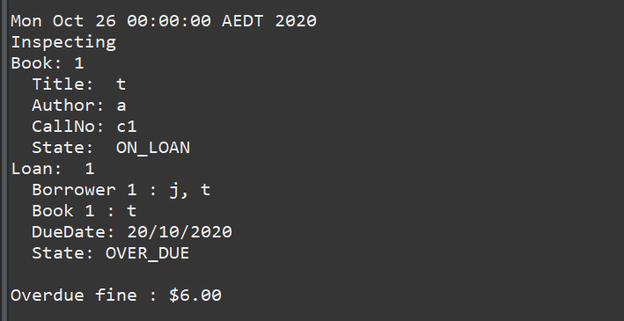

Hence 6 days overdue, 6 dollar fine.